Linux - Managing Users

Project Description
CLI commands – useradd, usermod, userdel, chown and more.

A new employee, researcher9 joins the organization. The following tasks are completed to add them to the system and manage their access during their time with the organization.
- Adding the user, and adding them to their primary group
- Making the user the owner of a file related to a project they will work on
- Adding the user to a supplementary group
- Deleting the user from the organizations system

Adding a User
The user is added using the command sudo useradd researcher9
The user is then added to their primary group using the CLI inputs sudo usermod -g research_team researcher9
NOTE: This task could be condensed into a single step using the command sudo useradd -g research_team researcher9
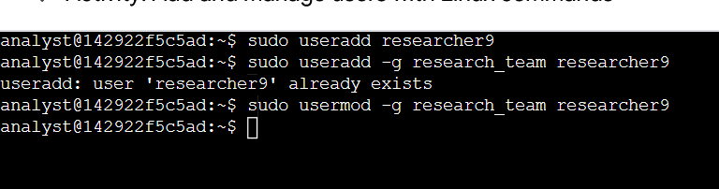

Assigning File Ownership
File “project_r.txt”'s ownership is changed from researcher2 to researcher9 using the following commands:
- the proper directory is navigated to cd /home/researcher2/projects
- the directory's contents are explored ls -la
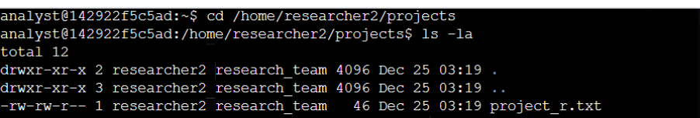
- The file's ownership is changed chown researcher9 project_r.txt
- Finally, the work is checked using the command ls -la

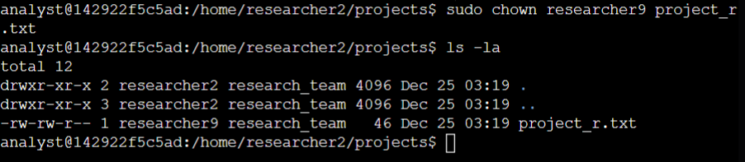

Command Semantics
ls – lists the contents in the current directory
ls WITH -l lists the permissions, owner and other information
ls WITH -a lists hidden files

Adding A User to A Secondary Group
The user is added to a secondary group sudo usermod -aG sales_team researcher9

Command Semantics
sudo – temporarily elevates CLI operator to root user (more or less)
usermod allows user modifications
usermod WITH -a used alongside the following command to append without overwriting
usermod WITH -G Adds supplemental group
sudo usermod -a -G <group> <username>

Deleting A User
1. The user is deleted using the command sudo userdel researcher9
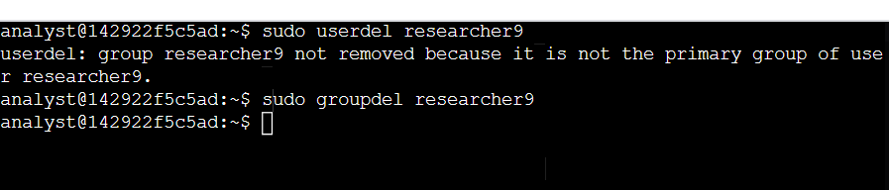
2. The users group is then deleted sudo groupdel researcher9

Summary
As a Cybersecurity Analyst, daily tasks like adding, deleting, and managing access to files for members of organizations are part of ensuring the security posture of the organization is sound. In this Task Report, some of the Linux CLI skills needed to manage members' ability to perform work in a safe way have been displayed. Thank you for your time : )

